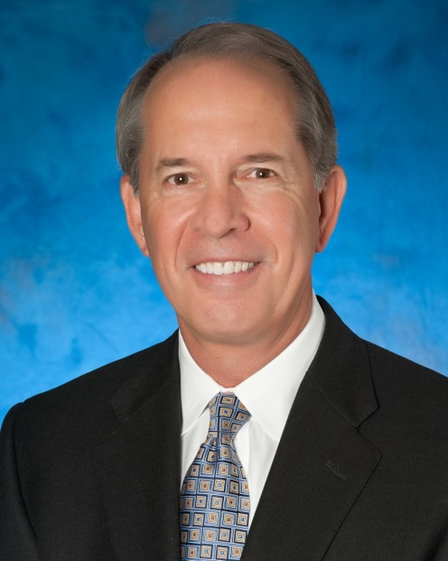
Bio—Philip R. Wood
Mr. Wood is currently a Principal in Silverside Partners, LLC, a private commercial real estate investment firm headquartered in Dallas, Texas. He has been associated with this firm since June of 2013 and is responsible for the accounting, finance and property management of the company’s investment portfolio.
From November, 2006 to May, 2013 he served as Executive Vice President in the Corporate Banking Group of Texas Capital Bank, a multi-billion dollar commercial bank headquartered in Dallas, Texas.
Prior to joining Texas Capital, he was co-owner, President and CEO of Premier Amusements, Inc., a regional amusement game company affiliated with the Cinemark Theater Group from 1984 until he sold it in 2004. During his time with Premier, he was also co-owner of Sunbelt Amusement & Vending, a regional wholesale distribution company.
From February 1979 to June of 1984 Mr. Wood served as Senior Vice President and Manager of the Commercial Banking Group for Texas American Bank, a multi-billion bank holding company based in Fort Worth, Texas. In that role, he also served as Vice Chairman of the bank’s Senior Loan Committee. Before joining Texas American Bank in 1979, he was a Vice President in the National Accounts Group with the First National Bank in Dallas where he began his business career.
He received his B.A. in Economics/Political Science from Rice University in Houston, Texas in 1972 and his M.B.A. in Finance from Southern Methodist University in Dallas, Texas the following year. He is also a past graduate of the Southwestern Graduate School of Banking at SMU.
He has served in various leadership roles with a number of non-profit organizations in the Dallas/Fort Worth area during his business career and is also a past Director of the Cotton Bowl Athletic Association.
He and his wife Peggy have owned a unit at The Palms for the past six years and since that time have attended and participated in every AGM held at the property. He has also served as Chairman of the Executive Committee at The Palms for the past two years.

